JMETER RESULT ANALYSIS

HTML Report Dashboard is a huge step forward simplifying JMeter test result analysis.

**Report Summary**

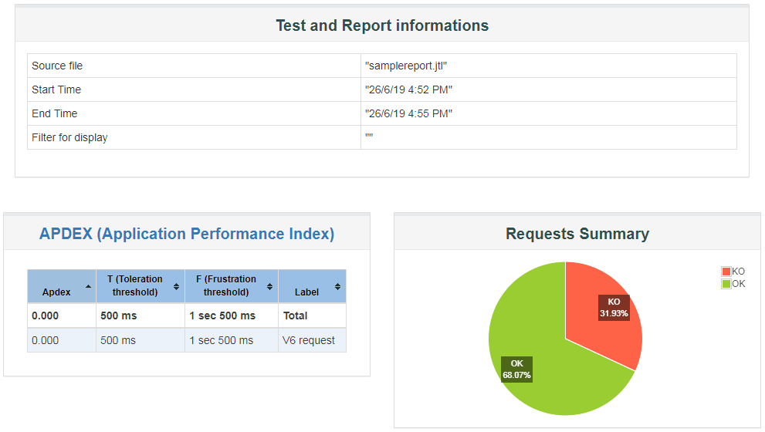

The Report Summary contains the following information:

* Test start time and end time,
* APDEX scores for every single request and container,

**(**APDEX is explained here

To compute it JMeter needs 2 values:

Satisfied count

Tolerating count

Satisfied count is the Number of requests for which response time is lower than “Toleration threshold”

Tolerating count is the Number of requests for which response time is higher than Toleration threshold but lower than “Frustration threshold”

So JMeter let’s you customize those 2 values as it depends on your SLR/SLA.

APDEX = (SatisfiedCount + ToleratingCount / 2) / TotalSamples**)**

* A pie chart named *Requests Summary* which gives the proportion of Successful / Failed samples.

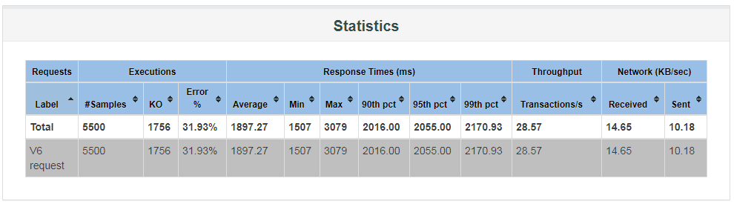

The **Statistics** table provides global test statistics for every single request which has been executed:

* **Executions**: Number of hits and errors,
  + **# Samples**: This indicates the number of virtual users per request,
  + **OK**: Total Number of samples executed successfully,
  + **KO**: Total Number of samples failed to execute,
  + **Errors %**: Percent of requests with errors,
* **Response Times (ms)**: Response times in milliseconds,
  + **Average**: The average response time for the request(s) executed,
  + **Min**: The lowest elapsed time for the samples with the same label,
  + **Max**: The longest elapsed time for the samples with the same label,
  + **90th pct**: 90th Percentile,
  + **95th pct**: 95th Percentile,
  + **99th pct**: 99th Percentile,
  + **Throughput**: Number of hits per second,
* **Network**: throughput in KB/sec

The throughput measured in Kilobytes per second

* + **Received**: KB received per second,
  + **Sent**: KB sent per second.

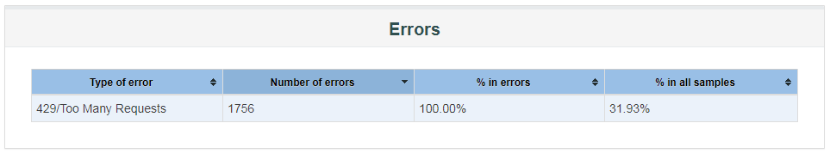

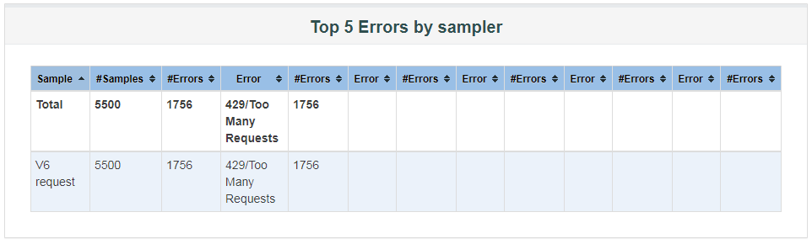

The errors table give more details about the errors encountered during the load test. For each type of error, you will see:

* **Number of errors**: how many errors occurred,
* **% in errors**: percentage of requests in error,
* **% in all samples**: Percentage of errors compared to total number of samples.

**Graphical Charts in Report Dashboard**

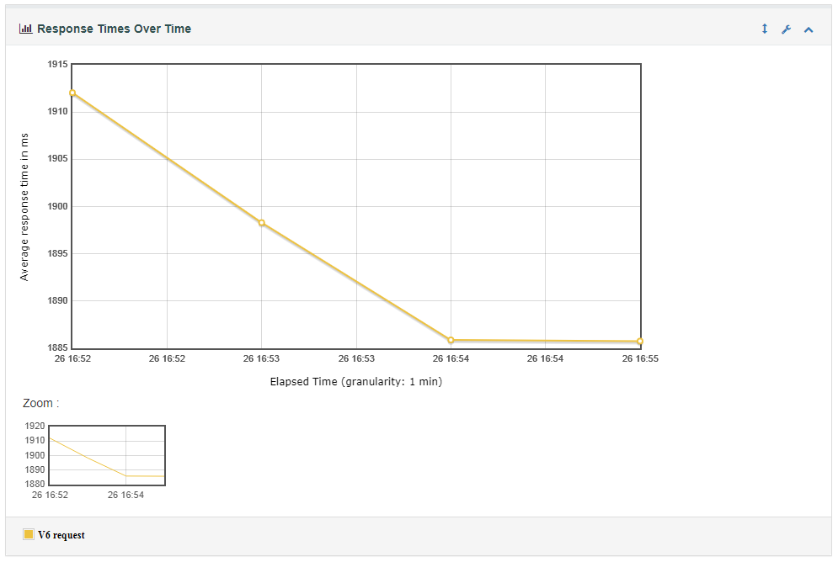

**Response Time Over Time**: It includes result from Transaction Controller Samples & represents the average response time over time.

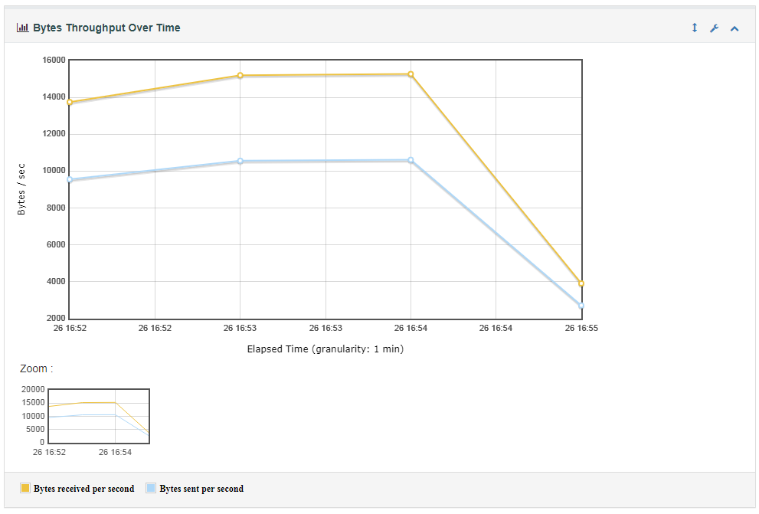

**Bytes throughput Over Time:** It ignores result from Transaction Controller Samples & represents the throughput of received and sent data over time.

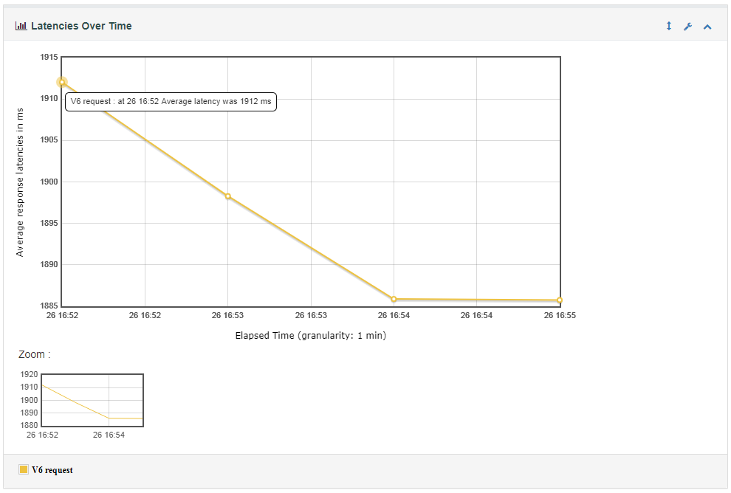

**Latencies Over Time:** It includes result from Transaction Controller Samples & represents the average latency time over time.

There are various charts you can find under index.html to analyse behaviour of test execution.